YNER Festival 29 FAMILY FUN DAY at GO APE.
Dare you take the challenge?
Go APE, Dalby Forest Dr, Low Dalby, Pickering YO18 7LT
Sunday 28th June 2026


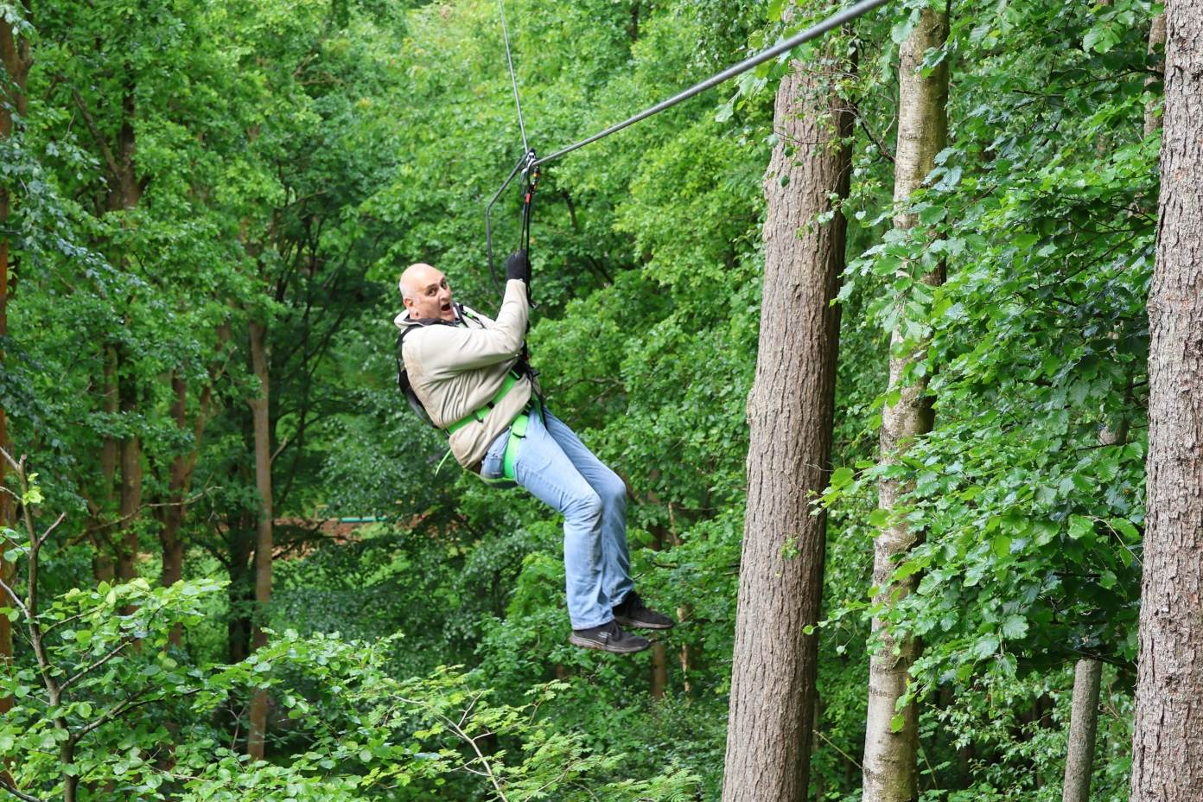

Treetop Challenge
2.5 hours for ages 10 years and above.
(1.4m 4’7’’tall and under 130kg 20.5 stone) £40.95 each
Start times 12 noon,12.30 and 13.00 (16 per group, max of 8 in groups aged between 10 and 18 years of age)

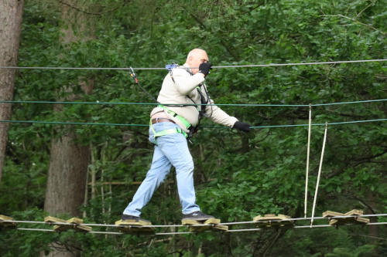

Treetop Adventure
1 hour for ages 4 years and above
(1m 3’3’’tall and under 130kg 20.5 stone) £24.95 each
Start times 12.45 noon,13.15 and 13.45 (16 per group, max of 8 in groups aged between 4 and 18 years of age)

Booking Form to:- jack.sharpe1@outlook.com
Limited numbers so book early
The booking is confirmed only when payment is received and you have received a confirmation email from Jack Sharpe

BOOKING FORM
YNER Festival 29 FAMILY FUN DAY at GO APE.
Treetop Challenge £40.95each Start times 12 noon,12.30 and 13.00
Lead name Name :- Under 18 Y / N
Party member 2 Under 18 Y / N
Party member 3 Under 18 Y / N
Party member 4 Under 18 Y / N
Party member 5 Under 18 Y / N
Party member 6 Under 18 Y / N
Party member 7 Under 18 Y / N
Party member 8 Under 18 Y / N

Treetop Adventure £24.95each Start times 12.45 noon,13.15 and 13.45
Lead name Name :- Under 18 Y / N
Party member 2 Under 18 Y / N
Party member 3 Under 18 Y / N
Party member 4 Under 18 Y / N
Party member 5 Under 18 Y / N
Party member 6 Under 18 Y / N
Party member 7 Under 18 Y / N
Party member 8 Under 18 Y / N

Preferred start time

Payment to by bank transfer to:-
Ac name: YNER Festival.
AC number: 04169654.
Sort code: 403301.
Ref;- go ape +lead name (eg:- goapeianbailey)

Please send this form to:- jack.sharpe1@outlook.com

What should I wear?
Gloves recommend for comfort.
We suggest that you wear something you don’t mind getting grubby. Dress for the weather so bring along a mac if the forecast is for rain.
You need to make sure you have the correct footwear which can’t fall off easily. This should offer protection to your toes and heel. Please do not wear sandals, flip flops, Crocs, slip-off or high heel shoes.
Your stomach area will need to be covered to prevent the harness rubbing, and long hair must be tied back to prevent entanglements in the equipment.

Tree top Challenge Highest plat form 16.6m
Longest zip line 225m

Tree Top Adventure highest plat form 8.7m
Longest zip line 90.5m

